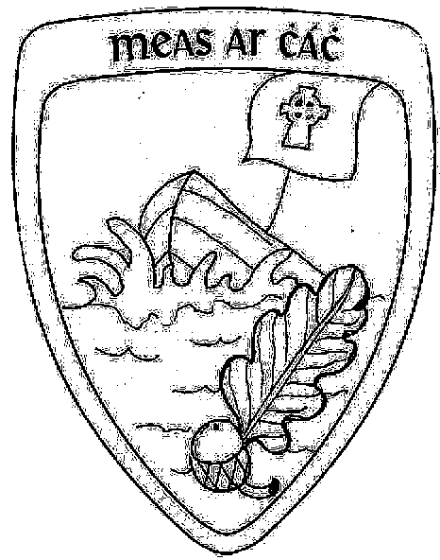
Scoil Naomh Erc.
Glenderry,
Ballyheigue,
Co. Kerry.
(066)7133827
scoilerc@gmail.com
www.glenderryns.com

Roll No. 18590A

Pre-Enrolment for ASD Class2024/2025

Child Information
Child’s First Name: __________________________________________________________________
Child’s Last Name: __________________________________________________________________________
Date of Birth:_____________________________ PPS No:______________________________
Note: All applicants must be at least 4 years of age on or before the 31st August 2024

Gender (please tick): □Female □Male
Previous school/pre-school/early intervention attended, if applicable:
____________________________________________________________________________________________________________________________________________________________________________________________________________________________________________________________

Parent/ Guardian Information
Mother’s Name(s):_______________________________________________________________
Father’s Name(s):_________________________________________________________________

Address: ______________________________________________________________________________________________________________________________

______________________________________________________________________________________________________________________________

Phone Numbers:(M):________________ (F): _____________________

Emails:(M):_____________________ (F): ________________________
I understand that:
- The receipt of the pre-enrolment form does not guarantee that the child will be offered a place
- It is my responsibility to inform the school of any change of contact details or other relevant circumstances.
- If I have not replied to a confirmed offer of a place for my child within 4 days of that offer being made, I will have forfeited my child’s place on the enrolment list.

Signed: __________________________________________ Date: _____________________
Signed: __________________________________________ Date: _____________________

Documentation
Please ensure that all of the following is supplied with the application as otherwise it will not be processed:
- An original birth certificate (with photocopy)
- A Diagnosis from a psychiatrist, psychologist or a member of a Multi-Disciplinary team that has assessed and classified the child as having autism or autistic spectrum disorder according to DSM-V or ICD 10 criteria and a recommendation for a placement in a special class within a mainstream school.
- Any other relevant reports – speech & language therapy/ occupational therapy and psychological reports.

Signed: _________________________________________ Date: ________________________
Signed: _________________________________________ Date: ________________________

Please send the completed application form to:

Scoil Naomh Erc, Glenderry, Ballyheigue, Tralee, Co. Kerry. V92TP94

For office use only
Receipt of FormDate:________________ | Report/Recommendations | □
Age:_______________ | Original birth certificate | □
Letter of offer sent date:________________ Accepted□ Declined□

